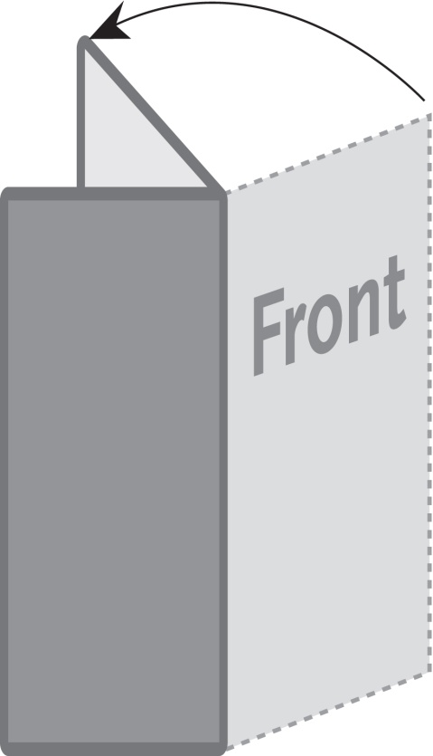
The image below is a sample image.
Insert the images for your brochure like this.
2 Panel Tall Brochure / Menu
4.25” x 11”
This is a sample text box.
Place the text for your brochure
in text boxes like this.

