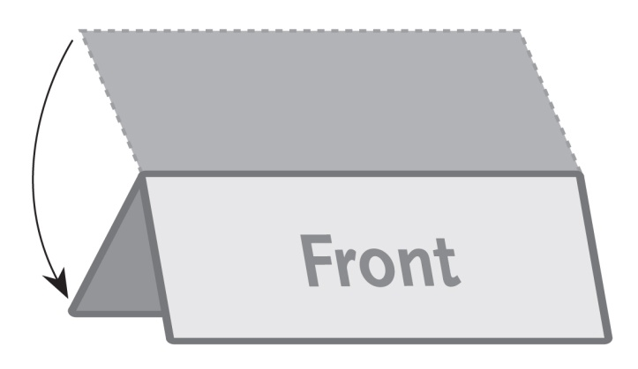
2 Panel Wide / Table Tent – 11”x4.25”
This is a sample text box. Place the text for your brochure in text boxes like this.
The image to the right is a sample image.
Insert the images for your brochure like this.

