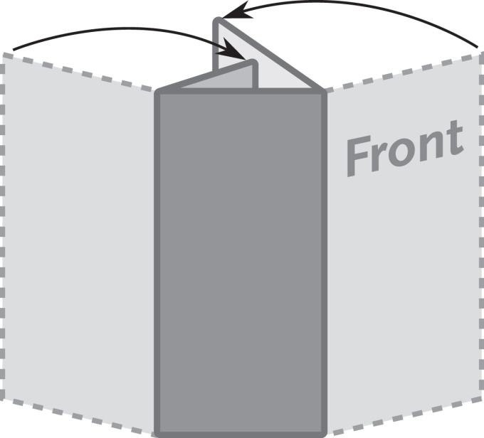
3 Panel Letter Fold Brochure
3.667” x 11”

This is a sample text box.
Place the text for your brochure in
text boxes like this.
The image below is a sample image.
Insert the images for your brochure like this.

