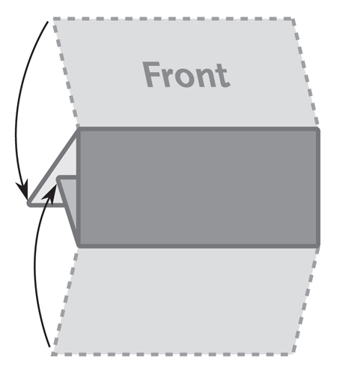
The image below is a sample image.
Insert the images for your brochure like this.
3 Panel Letter Fold
Brochure
8.5” x 3.667”
This is a sample text box. Place the text
for your brochure in text boxes like this.

