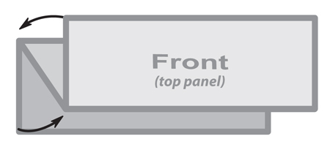
3 Panel Z Fold Brochure
8.5” x 3.667”

This is a sample text box.
Place the text for your brochure
in text boxes like this.
The image below is a sample image.
Insert the images for your brochure like this.

