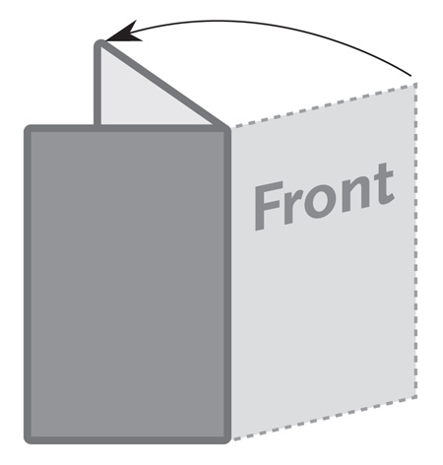
Half Fold
Brochure / Card
5.5” x 8.5”

This is a sample text box.
Place the text for your brochure in text boxes like this.
The image below is a sample image.
Insert the images for your brochure like this.

