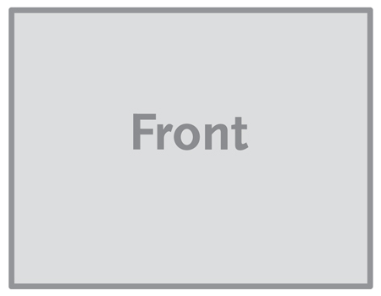
The image below is a sample image.
Insert the images for your brochure like this.
Single Sheet / Flyer - 11” x 8.5”
This is a sample text box. Place the text for your brochure in text boxes like this.

